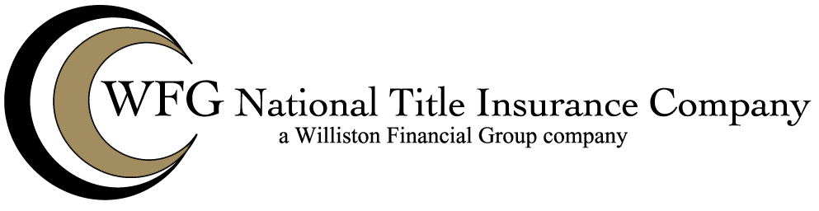

WFG NATIONAL TITLE INSURANCE COMPANY
ALTA 20-06 FIRST LOSS-MULTIPLE PARCEL TRANSACTIONS ENDORSEMENT

Attached to and made a part of policy number: ______________

This endorsement is effective only if the Collateral includes at least two parcels of real property.

1. For the purposes of this endorsement:

a. “Collateral” means all property, including the Land, given as security for the
Indebtedness.

b. “Material Impairment Amount” means the amount by which any matter covered by the
policy for which a claim is made diminishes the value of the Collateral below the
Indebtedness.

2. In the event of a claim resulting from a matter insured against by the policy, the Company
agrees to pay that portion of the Material Impairment Amount that does not exceed the
extent of liability imposed by Section 8 of the Conditions without requiring:

a. maturity of the Indebtedness by acceleration or otherwise,

b. pursuit by the Insured of its remedies against the Collateral, or

c. pursuit by the Insured of its remedies under any guaranty, bond or other insurance
policy.

3. Nothing in this endorsement shall impair the Company’s right of subrogation. However, the
Company agrees that its right of subrogation shall be subordinate to the rights and
remedies of the Insured. The Company’s right of subrogation shall include the right to
recover the amount paid to the Insured pursuant to Section 2 of this endorsement from any
debtor or guarantor of the Indebtedness, after payment or other satisfaction of the
remainder of the Indebtedness and other obligations secured by the lien of the Insured
Mortgage. The Company shall have the right to recoup from the Insured Claimant any
amount received by it in excess of the Indebtedness up to the amount of the payment under
Section 2.

This endorsement is issued as part of the policy. Except as it expressly states, it does not (i) modify any of the terms and provisions of the policy, (ii) modify any prior endorsements, (iii) extend the Date of Policy, or (iv) increase the Amount of Insurance. To the extent a provision of the policy or a previous endorsement is inconsistent with an express provision of this endorsement, this endorsement controls. Otherwise, this endorsement is subject to all of the terms and provisions of the policy and of any prior endorsements.

IN WITNESS WHEREOF the Company has caused its corporate name and seal to be hereunto affixed by its duly authorized officers on the __________day of _______, 20____.

Dated:

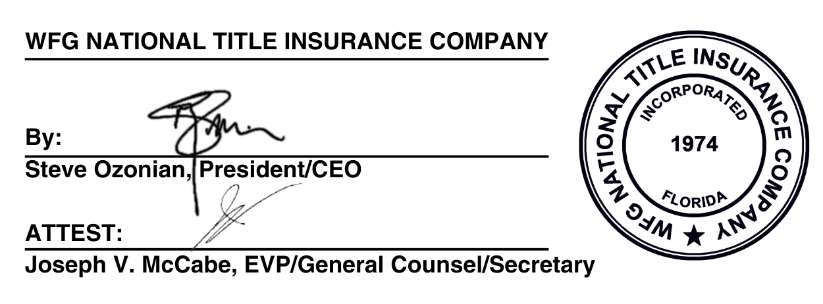
WFG NATIONAL TITLE INSURANCE COMPANY

By: _______________________________________
Authorized Signatory


Copyright 2021 American Land Title Association. All rights reserved.
The use of this Form (or any derivative thereof) is restricted to ALTA licensees and
ALTA members in good standing as of the date of use. All other uses are prohibited.
Reprinted under license from the American Land Title Association.

